The El Nino Dataset:
The folder RealApplication that stores the El Nino data set applied in the Real Application section of the manuscript, including the actual observations (ElNino_ERSST.csv), corresponding timestamps for observations (ElNino_ERSST_tpts.csv) and custom classification labels (ElNino_ERSST_label.csv).

The El Niño dataset is a well-known climate time-series dataset commonly used in time-series forecasting, anomaly detection, and regression modeling.
It contains oceanic and atmospheric measurements recorded over time in the tropical Pacific, measurements that help describe and predict El Niño / La Niña events.
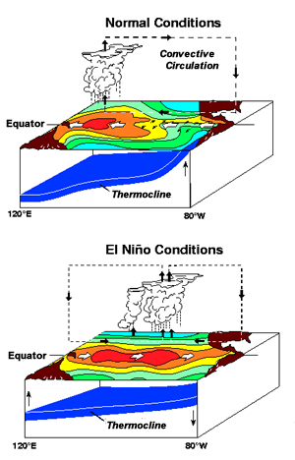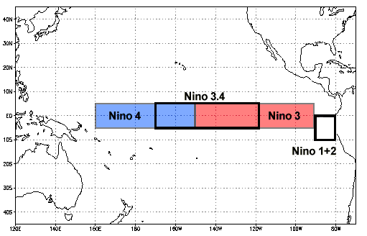

The “ElNino_ERSST” CSV part is the main data. The dataset typically includes monthly measurements. While variations exist depending on preprocessing.
Each of these 12 columns in the CVS file, represents a month of the year for a given year’s sequence. Also, we have 277 rows or observations.
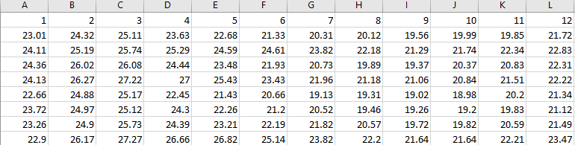

These values are usually SST anomalies, which means: Sea Surface Temperature (SST) Anomalies
- Temperature difference from long-term average
- Measured in °C
- Positive values → warmer than normal (El Niño–like)
- Negative values → cooler than normal (La Niña–like)
The dataset records these SST anomalies for a specific region, usually Niño 3, Niño 3.4, or Niño 4, depending on the version.

What the Goal of the Dataset Is?

1. Time-Series Forecasting: Predict future SST anomalies (Predict next month from previous months, Predict next year from past years, Predict onset of El Niño/La Niña). Example: “Given the last 12 months of SST anomalies, what will next month be?”

2. El Niño / La Niña Classification: Convert the continuous values into categories (El Niño, Neutral, La Niña) based on thresholds.

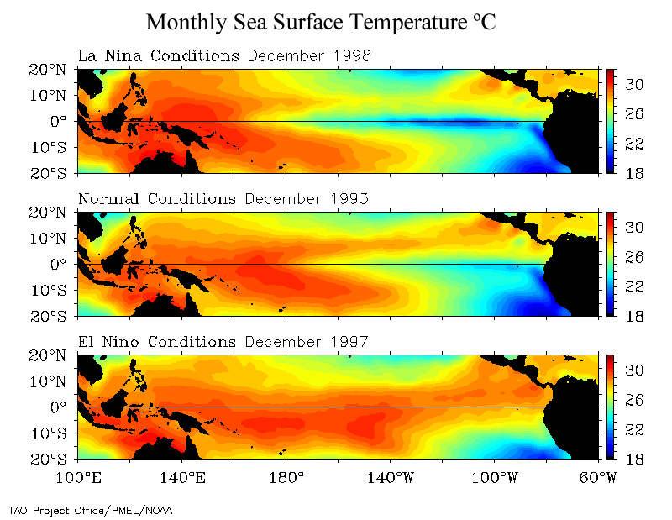

3. Anomaly Detection: Detect when SST anomalies depart from the normal range.

Implementing Regular FAE on El Niño dataset:
Now using Read_ElNino_Data.py file, we can read the data and by running FAE_regular as our model, it can learn a low-dimensional representation for each curve (n_rep = 5). Then, from that representation it reconstructs a smoothed version of the curve (FAE_pred_*).
In this model, we are training the whole FAE model 20 (niter) different times, each with a new random train/test split and new random initialization. And we have 5000 epochs with batch size as 28.
Classification: Then a logistic regression is trained on these representations to classify the curves into El Niño / Neutral / La Niña using label.
Outputs:
- X: centered original curves (still there)
- FAE_pred_all_niter: reconstructed curves from the model
- FAE_reps_all_niter: 5-dimensional representations for each curve
- accuracy and loss values for prediction and classification
Original vs reconstructed El Niño curves: Let’s take a look at a couple of these curves:
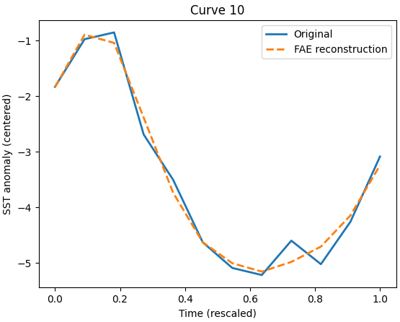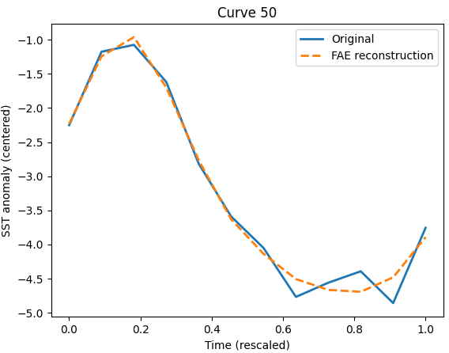
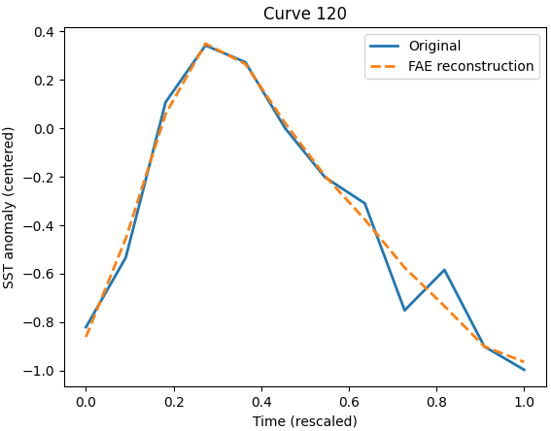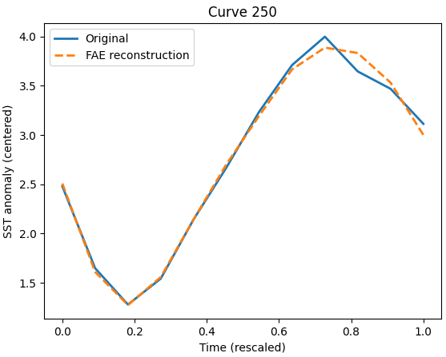

Why smooth in some places and not in others? Because the regular FAE’s reconstruction is limited by the fixed basis representation:
Region of curve | Behavior | Why
slowly varying | smooth | B-splines can represent it well
rapidly varying / noisy | jagged or oversmoothed | basis not expressive enough
peaks & troughs | biased | low-dim basis compresses extremes

We can increase basis size, or use nonlinear FAE.

Neural Network Architecture:
Input size = 12 (columns / Months)
Hidden layer (bottleneck): The latent dimension is 5 (n_rep / number of representation dimensions)
In ElNino_ERSST_label.csv file we have 4 labels:
Code | Meaning
1 | Strong La Niña
2 | Weak La Niña
3 | Neutral
4 | El Niño
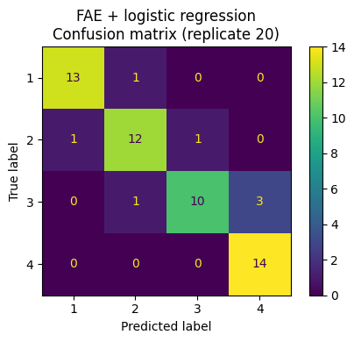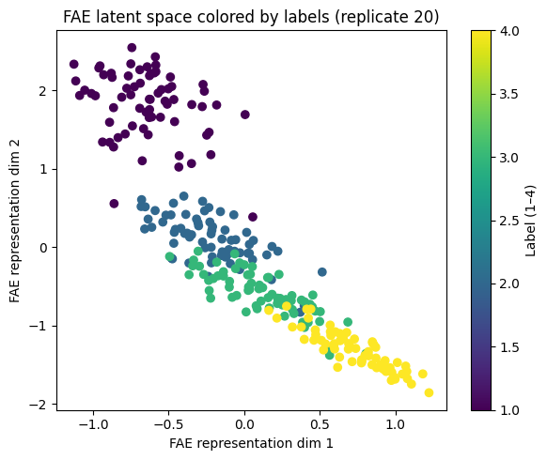
In regular FAE code, the classification is done after training, using logistic regression on the learned bottleneck features. The input of this Logistic Regression classifier is the representation (FAE_reps_train or bottleneck dim:5) and target is TrainLabel from 1 to 4. The accuracy of 20 replicates (last one ~91%):
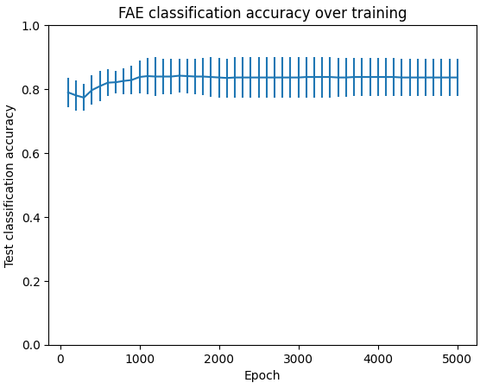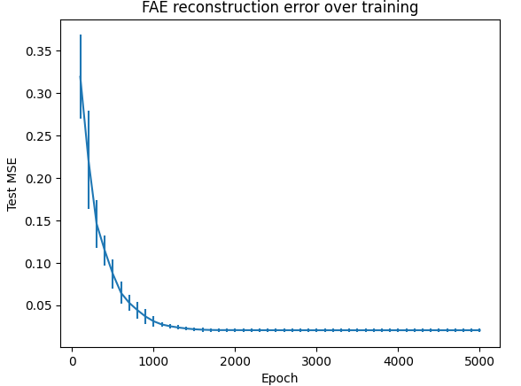
Let’s see the latent space (dim = 5) and compare the different categories:
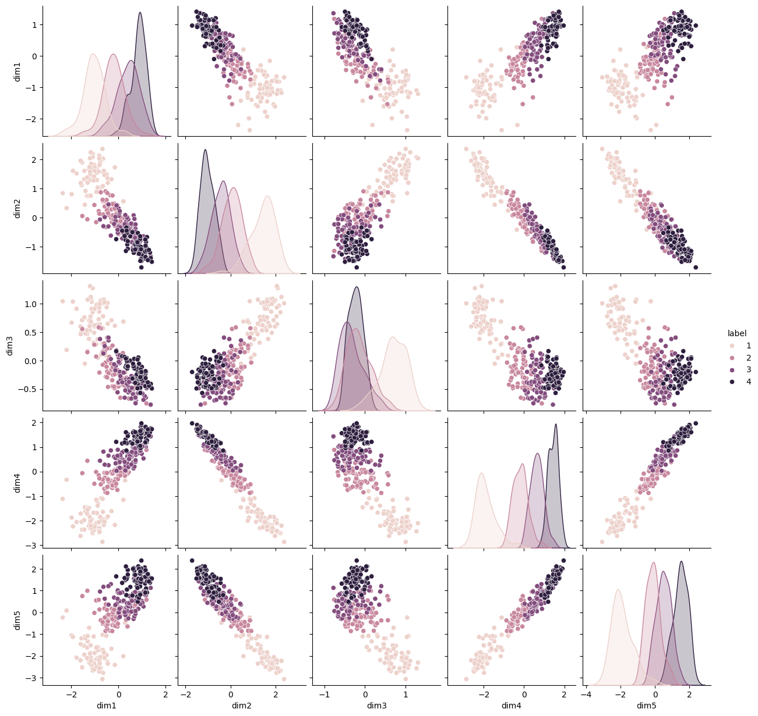

FAE and FPCA Comparison:
FPCA is exactly a linear autoencoder with Linear encoder and decoder, no nonlinear activation anywhere.
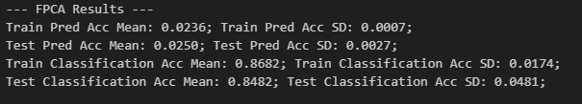
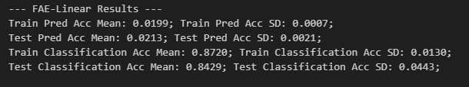
Paired t-tests:
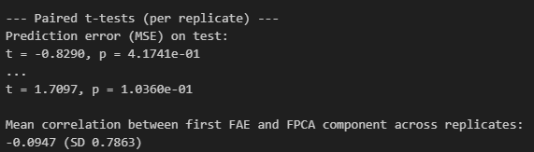
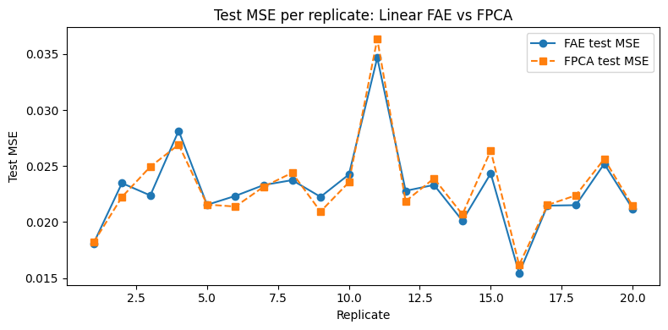

Difference between regular and irregular time points:
- Regular time points: Every observation is observed on the same, equally spaced grid: we can treat each curve as a vector $R^{j}$and use one common integration weight vector.
- Irregular time points: Each subject has its own time grid (different locations and/or number of points): we must integrate per curve with curve-specific weights, and we need a mask to say where data are actually observed.

Regular, equally spaced time points
Assume all curves share the same grid $t_{1},..., t_{J}$​ and grid is equally spaced or at least fixed.
You observe i-th curve as $X_{i}(t_{j})$ and approximate integrals with fixed weights $ω_{j}$​ (e.g. trapezoidal rule) which is called “feature layer” in the paper:
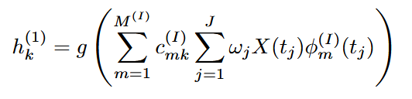
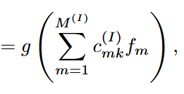

- These $f_{im}$​ are the features passed into the neural network.
- The weights $ω_{j}$ are the same for all subjects.
- The basis evaluations $ϕ_{m}^{(I)}(t_{j})$are also the same for all subjects.
- So the mapping $ω_{j}⟶ (f_{i1},...,f_{iM^{(I)}})$ is a single global linear map $R^{J}→ R^{M^{(I)}}.$ Where $M^{(I)}$ is simply the number of input basis functions used in the projection (feature extraction) layer of the regular FAE.
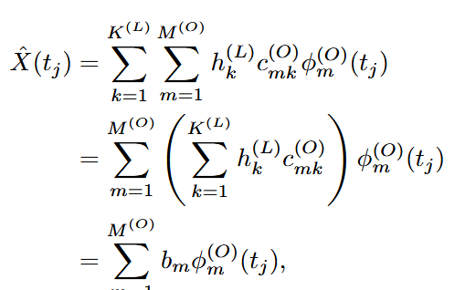
The decoder works similarly (Coefficient layer): if the last hidden layer outputs coefficients $b_{im}$,

On the same grids for every observation. no missingness and one global set of integration weights and basis evaluations.
Irregular time points
Now suppose each subject has its own grid: {$t_{i1},..., t_{iJ_{i}}$​}, $J_{i}$ can vary with i, not necessarily equally spaced, and often with missing chunks. The paper’s idea (Section 2.4) is: we still use the same basis functions, but we integrate curve-by-curve:
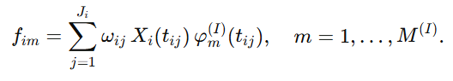
The key difference between these equations of $f_{im}$ in regular and irregular versions:
- The number of terms $J_{i}$ can differ for each subject.
- The weights $ω_{ij}$depend on the subject’s own irregular grid, not a common grid.
- Some t’s are simply missing for a given subject: they are not in the sum at all.
Those feature vectors $f_{i⋅}∈ R^{M^{(I)}}$ are all the same length, so after this step, all curves (even with irregular sampling) can be passed to the same neural network. The only real difference is in the encoder’s feature (projection) layer, because the integration step must adapt to irregular grids. Thus, the decoder is essentially the same in both the regular and irregular FAE. For reconstruction, we again use basis functions, but now we also use a mask:
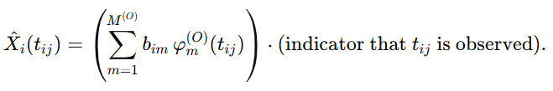
Integration is curve-specific (individual $ω_{ij}$). Loss is computed only at observed times (by masking unobserved locations).
Regular decoder code | Irregular decoder code
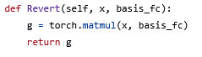 | 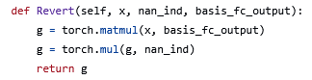  Second multiplication is the mask for irregular data.

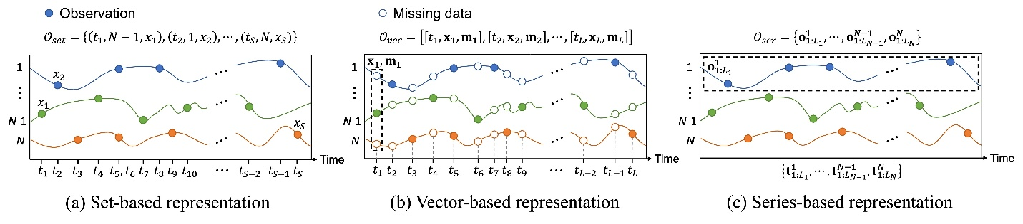
Main differences in the python code:
- Data representation: Omega holds the subject-specific weights $ω_{ij}$. missing_ind is the mask telling the model where data exist.
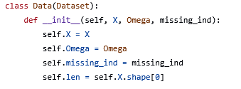
- Projection/feature layer: W is passed in from the dataset, not computed from a global tpts. So each mini-batch may contain different rows of W, corresponding to different irregular grids and weights $ω_{ij}$. Mathematically it’s doing
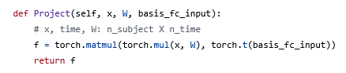
- Reconstruction with mask: First line: create a full curve on the dense grid where basis was evaluated.
Second line: multiply by nan_ind so that: Observed points keep their value. Unobserved points become 0 and effectively do not contribute to the MSE loss (because input also has 0s there).
That matches the paper’s description: when data are irregular, the loss is computed only at observed time points.
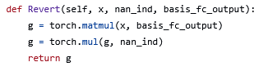
- Forward & training: Compared to the regular FAE: There are more layers and a nonlinear activation (Softplus): genuinely nonlinear mapping. W and nan_ind appear explicitly: the model is built to handle irregular grids and missing points.
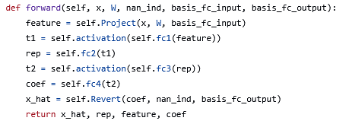
Regular and Irregular Comparison:
Component | Regular FAE | Irregular FAE | Same?
Input grid | Common grid for all subjects | Subject-specific grids | Different
Integration weights | Same vector (W) | (W_i) per subject | Different
Feature layer (encoder input) | One global integration | Per-subject integration; handles missing values | Different
Neural network layers | Linear or nonlinear | Nonlinear | Conceptually same NN mapping
Decoder (basis reconstruction) | $$\left(\hat{X}=B⋅{\text{basis}}_{O}\right)$$ | $\left(\hat{X} = B ⋅ {\text{basis}}_{O}\right),$ then mask | Same core mapping
Handling missing points | Not needed | Required (mask) | Different

